WAGNER SOCIETY OF IRELAND
NEWSLETTER DECEMBER 2017

Dear Member,

The next meeting of the Society will be WEDNESDAY 13th December at 8pm in the United Arts Club.

ADRIAN LE HARIVEL
Curator of British Art
The National Gallery of Ireland
will speak on the topic
THE MANY FACES OF WAGNER
Followed by Seasonal Drinks

In 2018 our meetings will be as follows,

MONDAY 15TH JANUARY AT 8PM
IRISH SINGERS OF WAGNER
PADDY BRENNAN

WEDNESDAY 21ST FEBRUARY AT 8PM
RICHARD WAGNER AND THE OPERA OF THE UNDEAD
PAUL ANTHONY MURRAY

MONDAY 12TH MARCH AGM

MONDAY 16TH APRIL TBC
WEDNESDAY 16TH MAY TBC

BAYREUTHER FESTSPIELE 2017
MICHAEL MARR

This year I was fortunate to obtain tickets for six operas at the Bayreuth Festival – for Der Ring des Nibelungen, Parsifal and Die Meistersinger.

Timothy King has already written a detailed and informative review of Frank Castorf’s controversial Ring production, featured in our October 2015 Newsletter, so I will not go over it again in detail.

However, the entertaining pre-performance talks given by Dr Sven Friedrich, Director of the Richard Wagner Museum in Bayreuth, cleared up some of the confusions from my previous attendance at this production of the Ring:

- Castorf set Das Rheingold in a sleazy motel on Route 66, USA. Why? Friedrich gave us the obvious explanation behind Castorf’s thinking: Route 66 = Texas = Oil = Black Gold = Rheingold! So that’s all right then!

- Wagner was a fan of Punch-and-Judy theatre. Indeed he had a set in Villa Wahnfried. You will recall that these childrens’ shows feature not only the characters of (obviously) Punch and Judy but also a crocodile. Hence the appearance on stage of the crocodiles in Siegfried. There were only two in the first production but because they were apparently so popular (?) with the audience or, as Dr Friedrich suggested, they had nothing to do but procreate in the off season, there were seven on stage this year. They were operated by acrobatic crew members and unfortunately served as a distraction from the beautiful music and the action: moving around the stage, causing chaos and even attempting to copulate.

- Castorf enjoys classic films, as evidenced by his replicating the pram-rolling-down-a–long-staircase from Eisenstain’s Battleship Potemkin.

I still found the production confusing and annoying, especially because of the distractions which caused one to wonder and speculate, rather than enjoy the words and music with which, thankfully, Castorf was not allowed to interfere:

- The Mount Rushmore monument, but featuring the huge head of Marx, Lenin, Stalin and Mao Tse Tung.

- The programme notes advised us that during Die Walküre there would be a very loud noise which would, however, not cause any permanent injury. Siegfried, instead of forging his sword Nothung as per the words he was singing, assembled an AK47 machine gun. The terrific noise in the acoustically perfect auditorium came when Siegfried killed Fafner with the AK47. Sure enough, we nearly fell out of our seats, but our hearing was not permanently damaged.

- The use of Patrick Seibert, Castorf’s chauffeur and assistant, in a non-speaking role. His appearances included that as a bartender in Das Rheingold and the bear in Siegfried. He got locked into a turkey cage (!) in Die Walküre, and was also the Turkish kebab and fruit-stand man (!!) in Götterdämmerung.

- But it got worse. Dr Friedrich speculated that Stefan Vinke, the excellent Siegfried, was planning something special. As this was the last performance, he might end Siegfried by rising to a high C with Brünnhilde rather than drop down an octave as per the score. And so it happened, what a thrill! But then he had to rescue the poor wood bird from the jaws of a crocodile, where she had disappeared with only her feet showing. What an anti-climax!

This was the last time this production would be shown complete in Bayreuth (sighs of relief all round). But in 2018 Die Walküre will be performed to make up the numbers. The new Ring is scheduled for 2020.

Uwe Eric Laufenberg’s 2016 production of Parsifal was set in the Middle East and showed a peaceful coexistence between Muslims, Jews and Christians. It was easier to understand than other previous, more obscure, stagings. Again Dr Friedrich’s lecture was helpful and accurate in its predictions. He explained Wagner’s concept of the Gesamtkunstwerk: a synthesis of music, drama, words and action. In this Parsifal, Dr Friedrich suggested, the audience would become part of the Kunstwerk: In the long Good Friday scene in Act 1 we would see suffering on stage; but we ourselves would suffer on the hard, uncomfortable seats in the auditorium. After 30 minutes we would start squirming, in pain, in a vain quest to find a relaxing position. This we would never find, but relief, of sorts would follow after about one hour as we turned numb. And so it was. But the music, the singing and the staging made up for it.

The new production for 2017 was Die Meistersinger von Nürnberg by Barry Kosky. He describes himself a “gay Jewish kangaroo” and his eagerly awaited staging, while unusual and perhaps somewhat controversial, was well received.

Act 1 opened in Wagner’s Villa Wahnfried. Wagner is on stage with his family and two black Labradors, as well as a younger Richard Wagner. They are joined by Franz Liszt and Wagner’s conductor friend Herman Levi. Wagner turns into Hans Sachs, young Wagner into David and Levi into Beckmesser. They are joined by the rest of the Meistersingers who emerge climbing out of a grand piano.

There is a comical church scene where everyone (except Beckmesser, because of his Jewish background) kneels. Eventually Beckmesser follows, only to be caught out again when everyone except him makes a sign of the cross.

These religious references, about religious differences, difficulties and anti-semitism, continue throughout the opera. At the end of Act 1, the scene changes to the courtroom of the Nuremberg Trials, also used in Acts 2 and 3.

At the end, in Act 3, Sachs turns into Wagner again. He stands facing the audience to sing his famous monologue, pleading that we listen to the voice of art. As he sings, an orchestra and the chorus appear on a huge wheeled platform which rolls toward the front of the stage. The (pretend) orchestra and the enormous chorus play and sing the grand finale. An emotional moment!

The singers in this excellent production included Michael Volle as an impressive Hans Sachs. Johannes Martin Kränzle’s Beckmesser was brilliantly acted and sung. Klaus Florian Vogt again had the role of Walther, as good as ever. Gunther Groissböck filled the minor role of Pogner.

My only disappointment at the time was Anne Schwanewilms who sang Elsa. I felt that her voice was totally unsuited to the role; this was confirmed to me later when I read reviews of the production, which called her singing “terrible” and her casting in the role as “disastrous”.

But, as usual, my six days in Bayreuth in 2017 were enjoyable: the sunny weather, the music and the singing, the Festspielhaus with some audience members (male and female) vying to outdo each other in the flamboyance of their outfits.

Michael Marr
October 2017

PS: Every time I attend a Wagner opera, I see a particular couple in the audience and also promenading during the intervals, each day in new, colourful, matching outfits. I don’t know if they are following me, or if I am following them. This year I finally spoke to them and, with their permission, took their photo. Here they are:

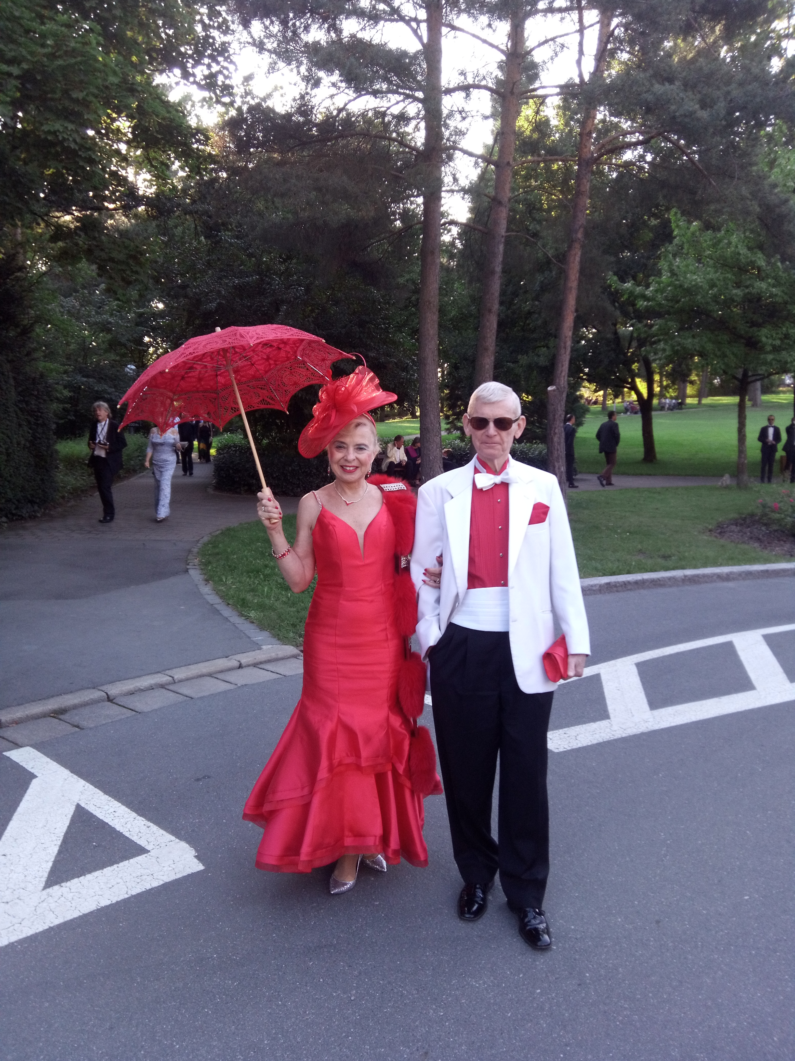

You’ll probably see them, Dick and Cathy Soderquist, US opera fan(atic)s if you go on our trip to the Ring in Leipzig in 2018.

PPS: If you have thought about going to Bayreuth but are put off by the prices for seats in the Parterre (~€300 each), here’s a tip: get tickets in the Balcony, in row 1 if possible. The sightlines are much better than towards the sides downstairs; the singers’ voices rise loud and clear, accompanied by the orchestra at just the right volume; no need to wear a tuxedo or that slinky long dress; and, best of all, tickets only cost around €50 each.

MM

DEUTSCHE OPER BERLIN
November 11/12 2017

The prospect of hearing Tannhauser and Lohengrin on successive nights in the excellent and acoustically perfect Deutsche Oper resulted in a travelling party of 34 making the journey to Berlin for a great weekend of opera. As in previous trips we were accommodated at the Steinberger and Ibis Hotels. The weather was crisp and the few showers did not deter visits to parks, galleries and of course shops. The Christmas Markets had not yet opened.
On our way to Tannhauser on Saturday evening I was reminded of the two ladies on holiday on the Riviera who would say to one another “Let’s go down to the beach to be scandalised. This production used no scenery throughout but instead had a number of striking set-pieces. The overture saw a vision of Tannhauser, in shining armour , being lowered Spiderman-like from the rafter’s into a bubble bath of nude women. Venusberg was a tableau of naked nymph’s rising and sinking above our line of sight. It is said that Wagner was going to call Tannhauser “The Mound of Venus” until he realised the awful jokes it would attract.
The chorus of pilgrims were depicted as being in, if not Hell, then Purgatory. Flames licked their naked bodies and on this occasion, they were all male. They were guarded by sinister looking winged gargoyles suspended from above. The singing contest was a feast for the eyes. It opened with 40 armoured warriors who were to the top of our sight line. The guests (chorus), who numbered over 200, were dressed in colourful medieval costumes and they took their places in tiered rows while the singers, in full armour, lined up at the front of the stage.
The final act took place in a hospital with Elizabeth tending 40 bed bound patients.
The German tenor, Andreas Schager (Tannhauser) and the English soprano Emma Bell (Venus/Elisabeth) seemed to struggle in the 1st Act when their singing sounded forced. As Elisabeth, Bell was a changed performer and for the rest of the performance her singing was thrilling and magical. Schager also improved but his unrestrained blasting of every high note did not sit easy with everyone. Markus Bruks as Wolfram was the audience favourite and he delivered his Evening Star aria perfectly. For many of us the abiding memory will be the singing of the DOB chorus who have achieved a level of exceptional quality. The Chorus of Pilgrims in the 3rd Act “Begluckt darf num dich” was breath-taking and could scarcely be bettered.
Conductor Martin Broder, reading the Dresden version of the score, added immensely to our enjoyment of the evening by giving the strings and woodwind full vent.
Finally the good mood that the stage performance engendered was added to by Michael Marr’s up to the minute report’s of the going’s-on in Lansdowne Road and Copenhagen, during the intervals.

Kaspar Holten’s production of Lohengrin has been acclaimed since first staged in 2012. From the prelude to the 1st Act he puts the wartime setting upfront when we see a corpse strewn battlefield which is visited by grieving women who go from corpse to corpse trying to identify the dead. The orchestral climax is accompanied by a heart-wrenching scream as one of the women recognises a dead soldier and the tone is set for much of what follows. Uniforms and the wounds of battle were to the forefront throughout. Klaus Florian Vogt gave a great account of himself in the title role. He arrived in a cloud of stage smoke with clip-on swan’s wings and wore a costume of flowing white. He looked like an angel and perhaps this robbed him of some of the humanity in his relationship with Elsa. He sang with clarity and intensity and it is clear to see why he is scheduled, next year, to play Lohengrin in Covent Garden and Parsifal at the Met. To our great surprise, before he gave a most poignant performance of “In fernem Land” he calmly took two sheets of white paper from his costume and gave them a quick glance before putting them away again!! The American soprano, Rachel Willis-Sorensen was every part the pure and virginal Elsa and from when she walked on to the stage blindfolded and sang “Einsam in truben Tage”with passion and beauty we were in thrall.
All of the leading voices were outstanding and it was a delight to have the opportunity to hear the great Wagnerian mezzo-soprano Petra Lang in the role of Ortrud. In recent times, she is an acclaimed Isolde, most recently in last years Katherina Wagner’s production in Bayreuth. Her exceptional singing was accompanied by an acting performance that left us in no doubt as to how evil Ortrud was.
The choral singing was of a level of excellence that one only gets at this house. We were privileged that Donald Runnicles was conducting. The work was beautifully paved with a level of emotional insight that gave a deeper understanding of this great work.
The performance ended with a shock when in the final scene the swan did not turn into a fully grown Gottfried but into the tiny corpse of a child. Neither did Elsa collapse dead nor did we see Lohengrin return to the castle of the Holy Grail. As the curtain came down the surprise among the audience was evident but it quickly recovered to give the production a standing ovation and multiple curtain calls.
Holten’s production left many questions unanswered including that Elsa may have been guilty after all. The consensus among our group was that we had seen an exceptional Lohengrin that will stay long in the memory.
No report of this trip would be complete without expressing everyone’s appreciation to Anthony for identifying two great productions, sourcing the tickets and not least, negotiating a very competitive hotel rate.
As in previous trips the many advantages of travelling as a group were evident and it was also good that the spread of the group went well beyond Dublin and also included new faces.

SEAN HOGAN

Thank you to all the contributors to the Newsletters in 2017.
The articles have been most engaging and informative.
We hope to see you on the 13th December for our Christmas meeting.

Happy Christmas to you and your families.

The Committee.

